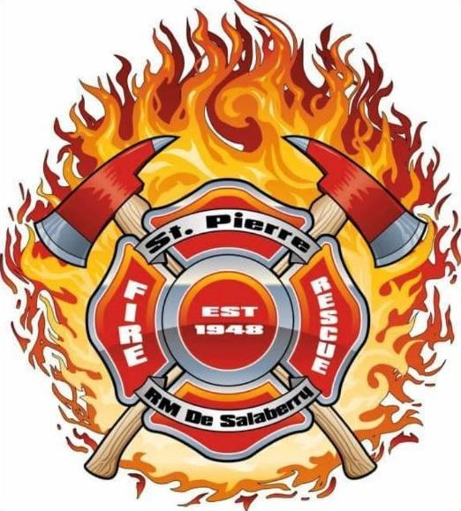
St-Pierre Fire Department
Box 598
St-Pierre Jolys, Manitoba
R0A 1V0
Requirements for candidates applying for Firefighter position:
All firefighter positions are Paid-on-Call (NOT full-time)
- Candidate must reside within the St-Pierre Fire AOR (area of responsibility)
- Must be physically fit to perform strenuous tasks (strength and fitness test may be required)
- Must be capable of working in a stressful environment
- Must work well with members in a team environment
- Must be able to follow strict and detailed orders
- Must be able to work at heights and in confined spaces
- Must be willing and able to learn new methods as required
- Must be willing to complete all required training and obtain necessary licences and certifications - Must have a valid driver’s license
- Must be able to attend evening and weekend training sessions
- Must be willing to have the Fire Dept apps on personal mobile device
- Must be able to respond to call outs 24/7 (when available and in the area)
- Must have the support of employer for attending call outs when possible.
- Must have the support of family to be able to commit to the time requirements of a paid-on-call firefighter
- Candidate may be required to adhere to provincial guidelines and or mandates
- Must provide a criminal record check and Adult / Child Abuse Registry check.
- Must be clean shaven for SCBA face piece seal
- Driver's Licence Abstract Required
Required training provided to all successful firefighter recruits:
- First Aid/ CPR
- Class 4 driver’s license/ air brake endorsement
- Incident Command 100 (online)
- Traffic Control seminar (1 day)
- Hazardous Materials Operations (40 hrs on 2 weekends)
- Firefighter level 1
- Firefighter level 2
- Vehicle Extrication seminar

